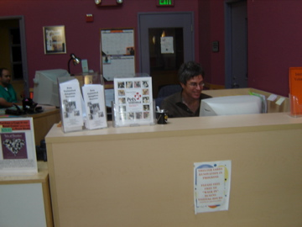 Podcast 6: Jonathan’s Job
Diane Wallis
December 11, 2006

Open the internet and go to: http://dianewallis.podomatic.com
Click on the episode: Jonathan’s Job
Listen to the podcast and answer the questions below.
Use the vocabulary to help you answer the questions.
Vocabulary:
Friday, Saturday, Sunday, petting, feeding, helping, took care of, helped, liked, pets, home, school, full-time, because, liked
adopt, Fillmore, Pets Unlimited, animal shelter, salary, playing

 | Questions | Answers
1. | Where did Jonathan work?
2. | What did he do at his job?
3. | What days did he work?
4. | What hours did he work?
5. | What was his salary?
6. | What did he like about his job?
7. | Why did he leave his job?

